**Group profiles**

**Group members:**

Jaya Narayan

Pallavi Sami

Elgene Menon Leo Anthony

**Location:**

3898782, Point Howard, Lower Hutt 5013

**Solar view results**

<https://solarview.niwa.co.nz/>

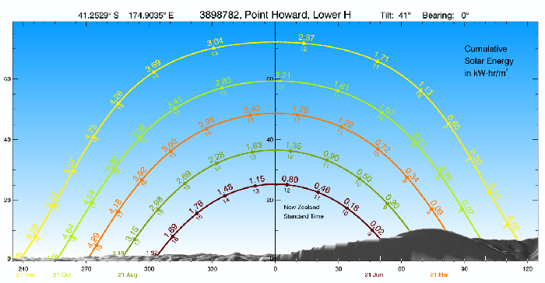

**Average sunshine for:**

Jun 21 : 1.92

Dec 21: 5.30

**Summer (Maximum energy consumption)**

|  |  |  |  |  |  |  |
| --- | --- | --- | --- | --- | --- | --- |
| **AC Load Description** | **Brand/Model** | **Quantity** | **Cost** | **Power Rating(kW)** | **Time on per day(h/day)** | **Energy used (kwhr)** |
| Refrigerator | Gram KS 3135-90 | 1 | $745 | 206kW/365  = 0.56kW | 8hrs | 4.48kwhr |
| Hot water cylinder | 325L Solar Storage with Electric Boost | 1 | $2292 | 3.6kW | 10mins * 3 showers a day *3 people= 1.5 hrs | 5.4kwhr |
| Electric Stove/oven | Westinghouse 60cm 'Mercury' Freestanding Oven | 1 | $1261 | 2kW for 2 burner elements | 2hrs | 2kwhr |
| Light | Standard Reflector Bulb R95 | 5 | $11.50  (one)  5x 11.50=  $57.50 | 0.075kW (One)  5x0.075= 0.38kW | 4 hrs | 1.5kwhr |
| Microwave | Samsung 28L Sensor Cook Microwave oven - ME6104ST1 | 1 | $249.00 | 1.5kw | 0.5 hr | 0.75kwhr |
| Laptops | HP Spectre 13-AF038TU Laptop | 3 | $2405 | 0.065kW *3=  0.195kw | 6 hrs | 1.17kwhr |
| Phone | OPPO AX7 Smartphone Glaring Gold | 3 | $349 | 0.05kW*3=  0.15kw | 4hrs | 0.6kwhr |
|  |  |  |  | **Total power used:**  **8.39kw** |  | **Total energy used:**  **15.90kwhr** |

**Winter (energy consumption (Max))**

|  |  |  |  |  |  |  |
| --- | --- | --- | --- | --- | --- | --- |
| **AC Load Description** | **Brand/Model** | **Quantity** | **Cost** | **Power Rating(W)** | **Time on per day(h/day)** | **Energy used (kwhr)** |
| Refrigerator | Gram KS 3135-90 | 1 | $745 | 206kw/365  = 0.56kW | 8hrs | 4.48kwhr |
| Hot water cylinder booster + wood burner | 325L Solar Storage with Electric Boost | 1 | $2292 | 3.6kw/4=  0.9kw | 10mins * 2 showers a day *3 people= 1hr | 0.9kwhr |
| Electric Stove/oven | Westinghouse 60cm 'Mercury' Freestanding Oven | 1 | $1261 | 0.5kw for 1 burner element | 2hrs | 1kwhr |
| Light | Standard Reflector Bulb R95 | 5 | $11.50  (one)  5x 11.50=  $57.50 | 0.075kW (One)  5x0.075= 0.38kW | 4 hrs | 1.52kwhr |
| Microwave | Samsung 28L Sensor Cook Microwave oven - ME6104ST1 | 1 | $249.00 | 1.5kw | 0.5 hr | 0.75kwhr |
| Laptops | HP Spectre 13-AF038TU Laptop | 3 | $2405 | 0.065kW *3=  0.195kw | 6 hrs | 1.17kwhr |
| Phone | OPPO AX7 Smartphone Glaring Gold | 3 | $349 | 0.05kW*3=  0.15kw | 4hrs | 0.6kwhr |
|  |  |  |  | **Total power used:**  **6.585kw** |  | **Total energy used:**  **10.42kwhr** |

**References**

[**http://www.lowenergyrefrigeration.co.nz/ks3135-90---135-lt-white.html**](http://www.lowenergyrefrigeration.co.nz/ks3135-90---135-lt-white.html)

<https://plumbingplus.co.nz/products/rheem-325l-solar-storage-with-electric-boost/?gclid=CjwKCAjwpuXpBRAAEiwAyRRPgaXlSHxe7jgwcNjq95HF7BjYIvdzx1hzKWQHaq1szqiGCHriO_H06xoCuEsQAvD_BwE>

<https://www.energywise.govt.nz/tools/lighting/?gclid=EAIaIQobChMI-83jsZ3m4wIVjYRwCh3VOwJUEAAYASAAEgKC5_D_BwE>

[**https://www.smithscity.co.nz/whiteware/cooking/microwaves/samsung-28l-sensor-cook-microwave-oven-me6104st1-8774960?gclid=CjwKCAjwscDpBRBnEiwAnQ0HQG5s4aUhzbKUdVbpXNwAd-nAFrnrqVI4nZf_VqfXpslxFcqSNEBlxxoC2oUQAvD_BwE**](https://www.smithscity.co.nz/whiteware/cooking/microwaves/samsung-28l-sensor-cook-microwave-oven-me6104st1-8774960?gclid=CjwKCAjwscDpBRBnEiwAnQ0HQG5s4aUhzbKUdVbpXNwAd-nAFrnrqVI4nZf_VqfXpslxFcqSNEBlxxoC2oUQAvD_BwE)

<https://www.harveynorman.co.nz/whiteware/kitchen/freestanding-ovens/westinghouse-60cm-mercury-freestanding-oven.html>

<https://www.noelleeming.co.nz/shop/phones-and-gps/mobile-phones/oppo-ax7-smartphone-glaring-gold/prod171394.html?&nst=SEM&gclid=EAIaIQobChMIzIik96Xm4wIVRAwrCh060gG3EAQYCCABEgIemPD_BwE&gclsrc=aw.ds>

<https://www.harveynorman.co.nz/computers/laptops/hp-spectre-13-af038tu-laptop.html?gclid=EAIaIQobChMIsrKHiKDm4wIVjIRwCh1YEATqEAQYAyABEgLNGfD_BwE>